Carr/Westberg/Baranowski

A Political Market Theory of Municipal Service Delivery Choice

Abstract

While research shows that transaction risks arising from the asset specificity and measurement difficulty of a service influence a city’s service delivery choices, the form of government is often treated as a mere control. This framing implies that elected mayors or appointed managers are unaffected by political structures when dealing with transaction risks. We advance a theory that form of city government shapes the link between transaction risks across alternative service delivery production modes. The theory follows the Political Market Framework, which suggests that the mayor-council structure is aligned with electoral incentives, whereas the council-manager form is allied with efficiency incentives. These incentive structures affect how city executives weigh risks and make choices. Our analysis finds that form of government does lead mayors and appointed managers to make different choices. .

The Political Market and Municipal Service Production Choices

## Introduction

The council-manager form of government is arguably the most important innovation in American municipal governance over the last 100 years. Scholars of municipal government have long asserted that this set of institutions has improved local government decision making by empowering administrative competence over political decisions (Frederickson et al 2003; Svara and Nelson 2008; Nalbandian, O’Neil, Wilkes, and Kaufman 2013). The municipal contracting literature also reflects this presumption. Within this area of study, researchers consistently share an expectation that municipalities with distinct forms of government to make different contracting decisions (Carr 2015). Despite this broad agreement on the importance of government form, the empirical research to-date is inconclusive about the role form plays in shaping service delivery decisions. This lack of clarity in the literature may be a surprise to many, because despite the absence of empirical support for performance differences between council-manager and mayor-council governments, these kinds of assertions have deep roots in the literature on municipal administration in the United States (Carr 2015).

We assert the limited progress made in resolving this question results from inadequate attention to theory. Indeed, the role played by the municipality’s form of government is rarely a central focus in these analyses. When it is included, it primarily serves as merely a control. In place of theory, common practice has been to offer vague assertions that differences in decisions are due to the adoption of “professional management” practices by “more innovative” “administratively-oriented” council-manager governments or from the “political motivations” and “voter orientation” of mayor-council governments (Brown and Potoski 2003; Levin and Tadelis 2010; Hefetz and Warner 2012; Hefetz, Warner, and Vigoda-Gadot 2014; Kim and Warner 2016).

We address this lack of a theoretical foundation directly by extending the “political market” framework (PMF) developed by Richard Feiock and colleagues (Feiock, Lubell, and Lee 2014; Lubell, Feiock, and Rameriz de la Cruz 2009) to municipal contracting. The PMF looks at the provision and consumption of local public goods as a market-based interaction between constituent groups demanding public goods and local public officials that supply them. In this paper, our attention is focused on the supply side decision of local public officials – Mayors or City Managers. They must ultimately choose whether to produce a public good directly or contract it out to another provider. Following Lubell, Feiock, and Ramirez (2005, 2009), the PMF asserts that these actors will make decisions based upon the incentive structures they face. Hence, Mayor-Council governments may well choose to produce the same public good through a different mechanism than a similar Council-Manager government.

Using a consumer choice approach, we model the public official’s policy choice as a political value maximizing decision. They will supply those goods at the level and through the delivery mechanism that maximizes their expected political benefit. We derive an economic theory of public contracting using the PMF. Then, we derive an econometric model that allows us to explore the differences in outcomes due to form of government. Our results reinforce results and message of Lubell et al. some fifteen years ago: Form of Government matters.

The next section will summarize the empirical work to-date on form of government. It will highlight the inconsistencies both in results and in assumptions, thereby clarifying the need for a coherent understanding of the provisioning of public goods. Section 3 will then develop our formal theoretical model and subsequently an econometric model. Then, Section 4 will estimate the econometric model, looking particularly at the Average Marginal Effects and the marginal effects of form of government. Finally, Section 6 will discuss the results and their important implications.

## Section 2: Does form matter? The evidence so far…

The existing literature has failed to establish a key role for form of government to date. About half of the studies seeking to link FOG to municipalities’ contracting outcomes report that form is not statistically related to these decisions (Morgan, Hirlinger, and England 1988; Lamothe, Lamothe, and Feiock 2008; Carr, LeRoux, and Shrestha 2009; Kwon and Feiock 2010; Kwon, Lee, and Feiock 2010; Shrestha and Feiock 2011). The remaining literature provides some statistical support for a linkage between FOG and contracting decisions, but it lacks consistency in those outcomes.

Three analyses provide empirical support for the proposition that council-manager governments are more likely than mayor-council governments to contract out for public services. Hefetz and Warner’s (2004) analysis of service delivery arrangements in 628 U.S. cities showed that council-manager governments were more likely to contract services out than mayor-council cities and were less likely to return services to in-house production once they had been contracted out. Levin and Tadelis’s (2010) analysis of service delivery arrangements in 1,043 U.S. cities in 1997 and 2002 showed that council-manager cities were slightly more likely to contract with other governments and nongovernmental (private and nonprofit) organizations than mayor-council governments.They concluded that “cities run by an appointed manager, rather than an elected mayor, are more likely to contract for service provision, although the effect is relatively modest” (p. 510). Finally, Hefetz, Warner, and Vigoda-Gadot’s (2012) analysis of service delivery arrangements in just over 1,400 cities and counties in the U.S. from 1992-2007 showed that those with a council-manager FOG were more likely to contract with other governments and for-profit suppliers.

Five studies assess the linkage between form of government and the use of specific sectors to produce public services, but the evidence is inconclusive. Brown and Potoski (2003) reported that council-manager cities were less likely to contract with private sector firms, but that form of government was unrelated to the likelihood cities opted to contract with nonprofits and other governments over in-house production. They also reported that council-manager cities were significantly more likely to engage in joint contracting, internal production, and complete contracting with other governments than contract out to private firms. Feiock and Jang (2009) found that council-manager cities were more likely to contract elder services to nonprofits than mayor-council cities and were more likely to use joint arrangements when they did.Contrary to Brown and Potoski (2003), Hefetz and Warner’s (2012) analysis of the service delivery arrangements used by 118 U.S. cities in 2007 found that the presence of a council-manager government decreased the likelihood of the service being produced by a nonprofit organization, but had no effect on the other sector choices. Hefetz, Warner, and Vigoda-Gadot (2012) analysis of the service delivery arrangements used by cities and counties in the U.S. found council-manager governments were more likely to rely on other governments and for-profits than were mayor-council governments. Finally, Kim and Warner (2016) found that council-manager governments used for-profit contractors for more services and other governments for fewer services than did the mayor-council governments in their sample of 1,580 U.S. cities in 2012.

In short, there is a seemingly clear understanding that managers contract out more services than Mayors. But, there is neither a clear pattern nor theory as to the ultimate choice of external provider. In some instances the results are even contradictory. As we will outline below, we feel this is due to an incoherent foundational theory of public contracting.

More in line with our thesis, three studies in this literature provide insights into potential conditional effects of form of government (FOG) on service production choices. Levin and Tadelis (2010) studied the moderating effect of FOG on the relationship between contracting difficulty and the use of external providers, but found no difference between manager and mayor forms of government. Hefetz and Warner (2012) and Hefetz, Warner, and Vigoda-Gadot (2014) included separate estimations of their models for council-manager and mayor-council governments, providing some insights into the contingent effects of FOG. Their analyses also generate inconclusive results. Hefetz and Warner (2012) find no evidence that form of government matters. In fact, their results suggest that transaction costs play little, if any, role in shaping the choice of service delivery mechanism. Hefetz, Warner, and Vigoda-Gadot (2014) create new asset specificity and measurement difficulty metrics based on survey responses. Their new measures provide empirical support that transaction costs matter, but their methodology makes it impossible to assess whether statistical differences exist due to FOG. The clearest finding is that the decision to contract with a for-profit establishment appears to differ on form of government and transaction costs. Mayors seem less likely to contract with for-profits when asset specificity increases. City Managers appear more likely to contract with a for-profit when measurement difficulty increases.

In sum, the extant literature on FOG and its relation to the service delivery choice has failed to produce a coherent picture. Much of the literature reports null findings and the rest is mixed in the relationships uncovered. Even worse, this literature rarely examines FOG as contingent factor influencing other variables of theoretical interest. In our view, this is due to the lack of appropriate theory construction to date. We move to improve this situation in the next section, outlining a formal theory of public service delivery choice that is grounded in the Political Market Framework (PMF) to inform our understanding of alternative service delivery choices.

## Section 3: A Model of Public Choice

This section derives a theory of public service delivery. Following Hayes and Wood (1995), we view public officials as utility maximizing individuals. One of their central responsibilities is to oversee the implementation of legislative decisions. We explore this decision but do so under the context of uncertainty. These agents make decisions today based upon their expectations of future benefits (i.e. “success” in whatever form that takes), which are largely shaped by their individual absolute and relative aversion to risk. We set up our political value (PV) function below.

$PV\left(g_{i},x_{i}\right)= \frac{1}{β} g_{i}^{1-α}+ \frac{1}{ϑ} x_{i}^{1-α}$ [1]

We assume that public officials are, on average, risk averse. However, as more resources become available to said officials, our model assumes they will become less risk averse.*[1]* The model also assumes that public officials will roughly allocate the same share of their resources to a given risky investment. Although this assumption is not ideal, it provides a foundation upon which to construct an internally consistent theory of public service delivery.

Equation [1] claims that the a public official derives political value from her spending decisions on public goods and in the distribution of that spending between internally ($g_{i}$) and externally produced public goods ($x_{i}$). However, that political value is modified directly by political risk ($\frac{1}{β}$), which we based on the inherent transaction risks associated with a specific public good. Specifically, we describe $β$ as a function of asset specificity ($ρ$) and measurement difficulty ($μ$).

We also assume that these political risks vary by service delivery mechanism. Risks associated with internal production ($\frac{1}{β}$) may, for good reason, differ from the risks associated with external production ($\frac{1}{ϑ}$). Importantly, this is also true for different external service delivery mechanisms (${\frac{1}{ϑ}}_{i}$). In fact, as we will show shortly, these external service delivery risks are the key factor driving the marginal choice of external service delivery mechanisms.

Finally, the political value function is dominated by the public official’s degree of risk aversion ($α$). Officials that are relatively risk averse will have a larger $α$ than an official that is less risk averse. More risk averse officials will focus on low-stakes investments, spending less on public goods than their less risk averse counterparts. We model risk aversion relying on political institutions. We make the basic assumption that communities that organize their elections around aggregated preferences will generate riskier political environments. Meaning, as political/electoral institutions move voting interests from diverse and hyper-local interests, the macro-political environment will become riskier for the public official.

Given this setup, we then construct our official’s quasi-demand curves for both internally and externally produced goods. We illustrate them both in equations [2] and [3] below.

$g_{i}^{*}= \frac{B}{p_{g}} [ \frac{1}{( 1+{\left(\frac{p_{g}}{p_{x}}\right)}^{\frac{1-α}{α} }{\left(\frac{β}{ϑ}\right)}^{\frac{1}{α}} )} ]$ [2]

$x_{i}^{*}= \frac{B}{p_{x}} [ \frac{1}{( 1+{\left(\frac{p_{x}}{p_{g}}\right)}^{\frac{1-α}{α} }{\left(\frac{ϑ}{β}\right)}^{\frac{1}{α}} )} ]$ [3]

These demand curves tell a similar story. The factors that matter most in this decision are: total resources available (B), direct costs ($p_{i}$), the relative price $\left(\frac{p_{g}}{p_{x}}\right)$, the relative risk ratio $\left(\frac{β}{ϑ}\right)$, and ultimately the degree of risk aversion ($α$). The curves are also structured the same. There is a structural element (i.e. the amount of internal or external goods that the official can afford) and a diminishing element that varies in important and impactful ways.

Equations [2] and [3] can tell us several important outcomes driving the decision-making process of our public official. Regardless of the choice to produce internally or externally, the following relationships are true[2]:

1. As B , total spending rises.
2. As direct costs ($p_{i}$) $↑$, total spending falls.
3. As relative costs ($\frac{p_{g}}{p_{x}}$) $↑$ and/or as relative risks $\left(\frac{β}{ϑ}\right) ↑$, demand falls and shifts toward the other service delivery option.
4. As $α$ $↑$, the effects of the relative price and risk ratio are minimized.
5. The relative risk ratio is more important to the determination of changes in spending levels than the relative price ratio.

With our choice model constructed, we now turn to the Political Market Framework (PMF) to properly specify these parameters and explain why Mayor-Council and Council-Manager governments will reach different optimal service delivery decisions and what those preferences will be.

## Section 3.1: The Political Market and the Supply of Public Goods

*Political Institutions*

The Political Market Framework (PMF) asserts that political and electoral institutions will play contingent roles in policy decisions (Lubell, Feiock, and Ramirez, 2005). These contingent effects play out by shaping the relative importance of other factors in the decision-making process. In our model this role is played by the degree of risk aversion. In line with Kwon et al. (2010), we argue that the degree of risk aversion is structured by the political climate within the community, driven largely by political and electoral institutions. As these institutions increasingly aggregate voter preferences (i.e. at large elections – including the mayor - and party-based elections), each policy choice becomes more broadly visible and consequently faces greater political risk. Therefore, we view $α$ as the differentiating characteristic in describing Mayor-Council and Council-Manager cities.

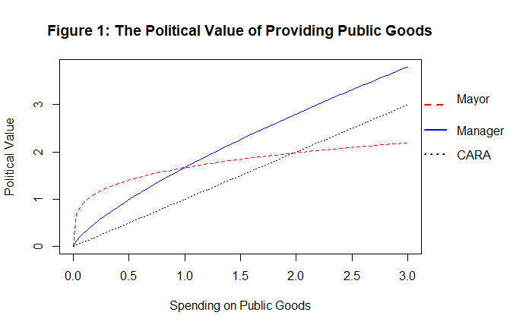

Figure 1 illustrates this distinction. We plot two political value functions, one at a low level of $α_{CM}$ (Manager) and another at a higher value of (Mayor).[3] The Mayor’s political value function highlights her relatively more intense risk aversion. At low levels of spending on public goods, Mayors expect to acquire more political value than a Managers. But, as spending levels rise, Mayors perceive smaller and smaller incremental benefits. However, Managers receive far more political value from higher levels of spending than Mayors. We also include a value function for a public official that exhibited Constant Absolute Risk Aversion for comparison purposes. Starting with that function, Figure 1 illustrates that as $α_{i}$ rises, the function exhibits increasingly greater diminishing returns to spending on public goods.

According to our model and its implications outlined above, the following propositions should hold:

### H1: Mayor-Council governments are, on average, more risk averse than Council-Manager communities.

### H2: The degree of risk aversion should be exacerbated (i.e. $α_{MC} ↑$) for Mayor-Council cities that organize elections around political parties and/or elect politicians to at large positions.

*Transaction Risks*

Every public service produced carries risk due, in part, to the asymmetric information problems of adverse selection and moral hazard (Rodriguez, Tavares, and Arajo 2012). The degree of risk inherent in the production of a good depends on the characteristics of that service and whether that good is produced internally or externally. Goods that are difficulty to produce often require specialized capital and/or infrastructure. Such goods are often described as asset specific. Highly asset specific goods can lead to monopoly conditions and otherwise “thin” markets. Other public goods, and services in particular, are difficult to measure in terms of output. This measurement difficulty generates increasing monitoring and enforcement costs as the good/service increases in its complexity. Both asset specificity and measurement difficulty create risk for public officials, but we argue those risks are different due to the incentives they face.

We model transaction risk using a internal production risk parameter ($β$) and an external production risk parameter ($ϑ$). Both parameters are viewed as functions of asset specificity ($ρ$) and measurement difficulty ($μ$). The empirical work to date has established two consistent findings. First, transaction costs have nonlinear effects. Higher levels of asset specificity and/or measurement difficulty have differential impacts (Brown and Potoski, 2003; Carr, LeRoux, and Shrestha, 2009; Shrestha and Feiock, 2010; and Rodriguez, Tavares, and Arajo, 2012). Second, risks to internal production are rising with asset specificity, whereas increases in measurement difficulty tend to lower the transaction risks associated with internal production (Brown and Potoski, 2003; Levin and Tadelis, 2007; Kwon, Lee, and Feiock, 2010; Shrestha and Feoick, 2010). Based upon these previous findings, we model internal and external transaction risks following equations [4] and [5] respectively. There are two differences. First, we do not indicate that internal risk will react to asset specificity and measurement difficulty in the same way. Second, we still view measurement difficulty as positively related to external production risk.

$β_{i}= γ_{1}ρ_{i} + γ_{2}ρ_{i}^{2}{- γ}_{3}μ_{i}- γ_{4}μ_{i}^{2}$ [4]

$ϑ={ δ}_{1}ρ_{i} + δ_{2}ρ_{i}^{2}{+ δ}_{3}μ_{i}+ δ_{4}μ_{i}^{2}$. [5]

These risks may present substantial problems to a public official. When faced with the tradeoff between bureaucratic management ( $β)$ and external contract risks ($ϑ$), the public official is evaluating the political value of their efforts (Sclar, 2000, Carr et. al 2004). Their political value function is maximized when the service delivery mechanism minimizes this transaction risk (Rodriguez, Tavarres, and Arajo 2012). Public officials then choose the service delivery mechanism that meets this decision rule.

The PMF asserts that Mayors face high-powered incentives (Frant, 1996). The benefits and costs of a policy action accrue to them individually. Therefore, Mayors are constantly facing a credit/blame decision. Do they attempt to take credit for the provision of some good or service? Or, due to their risk averse nature, are they more in need of a means of shifting blame? Asset specificity presents a short-term problem: high cost projects. Measurement difficulty, on the other hand, presents a longer-term problem: inability to quantify public benefits. Given their wins and losses accrue to them individually, a Mayor would presumably be far more concerned with short-term rather than long-term effects. Asset specificity should be a bigger concern for Mayors than measurement difficulty.

Our model reinforces this perception. Assigning the same exact transaction risks to each actor, Figure 3 illustrates the differences in behavior to increasing asset specificity.

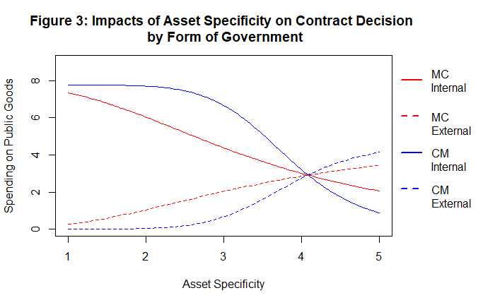

Mayors are far more sensitive to asset specificity at low levels. They quickly alter their distribution of spending between internal and external production of the good. Managers, on the other hand, do not move to joint production at low levels of asset specificity. In fact, our model indicates managers are more likely to remain in direct production at such low risk levels. However, as the risk from asset specificity rises, Managers move quickly to redistribute their spending patterns. As the risk rises, both actors move increasingly toward external production.

Managers, on the other hand, face low-powered incentives. The benefits from their policy decisions/actions accrue to the organization, not the manager individually. As a direct consequence of their incentives, Managers are more interested in building and maintaining a professional reputation over time. Consequently, we should expect Managers to be far less concerned about long-run investments than Mayors. These investments may be more complex and much larger scale than the short-term options more attractive to Mayors. Successful completion of such projects will only help to improve the Manager’s reputation. Therefore, we expect Managers to be far less sensitive to asset specificity than Mayors, although highly asset specific goods raise significant risks about future tax increases. In these cases, we expect Managers to contract with other governments to provide the service. Measurement difficulty is likely more a concern to Managers as failure to account for public expenditure reflects directly on him/her. Given their desire to maintain their reputation, we expect managers to bring hard to measure services in-house and under their direct control. Figure 4 highlights this takeaway.

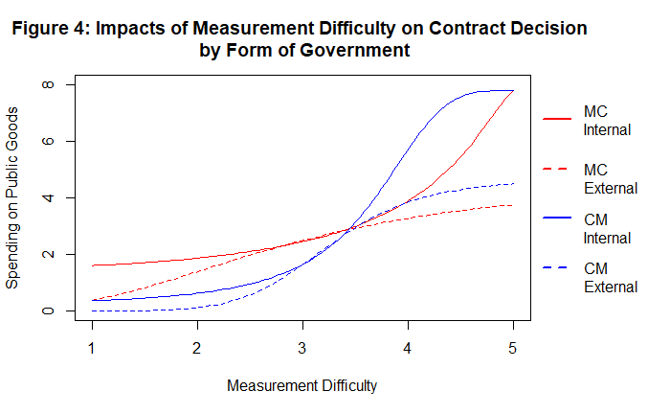

At low levels of measurement difficulty, Managers behave largely the same as Mayors. Mayors have a clear preference for internal production of difficulty to measure goods, but this is particularly true at low and very high levels of risk. The key distinction between the two groups is that managers appear to have a stronger relative preference for internal production as measurement difficulty exceeds moderate to high levels.

### H3: Mayors will be more sensitive to Asset Specificity at low levels of risk.

### H4: Managers will have a weaker preference for internal production at low levels of measurement difficulty than Mayors and vice versa.

*Relative Costs*

The costs of service production are rarely incorporated directly into empirical research. Instead, researchers have focused on degree of competition in these markets for public goods. Kwon et al (2010) include the number of establishments per county population and the number of nonprofits per city population. When the rate of establishments is large, it suggests there are likely a number of competing firms for public contracts. This reduces the adverse selection problem inherent in asset specific goods, but more importantly, it also suggests the relative price of external production will be more in line with the cost of direct production. The opposite is true when the rate of establishments and/or nonprofits is low. Here we expect the firms with monopoly power to produce public goods at much higher costs.

Our model demonstrates a somewhat complex relationship between the price ratio and the form of government’s contracting decisions. Figure 5A below illustrates the impact of an increasing relative price ratio on demand when the relative risk ratio is fixed at one, i.e. where the risk of internal production equals the risk of external production. Where the price ratio is less than one, internal production costs less than external production. In this range, we see that both officials prefer internal production. However, we also see that Mayors are much more sensitive to small changes in the price ratio than Managers. This story changes when the cost of internal production is greater than external production. In both cases, officials will allocate a larger share of their respective budgets to external production. Yet, in this range, Managers are far more sensitive to changing prices than Mayors.

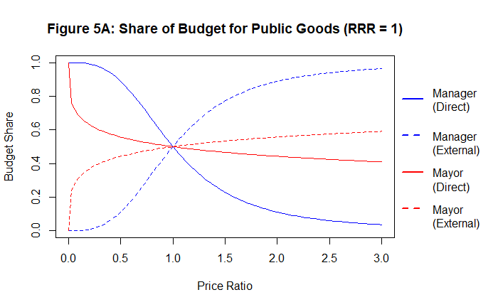Figure 5B illustrates the outcomes when the relative risk ratio is greater than one – internal production is riskier than external production. Mayors move away from internal production even when the price of internal production is much cheaper than external production. Managers follow suit, but appear more willing to take advantage of low-cost production, though they too move away from direct production far before the relative price ratio reaches unity.

Figure 5C illustrates the remaining case, wherein the relative risk ratio is less than one. In this low-risk environment, we see that Managers are now willing to engage in direct production even when internal production is much more expensive than external production. Although Managers’ behavior changes substantially due to the relative risk ratio, the figure also illustrates the extraordinary effect this has on Mayors. The relative price ratio that would move a Mayor out of direct production is, in this simulation, three times larger than the same threshold price for Managers.

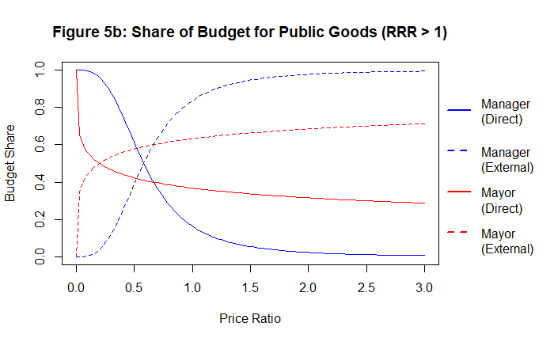

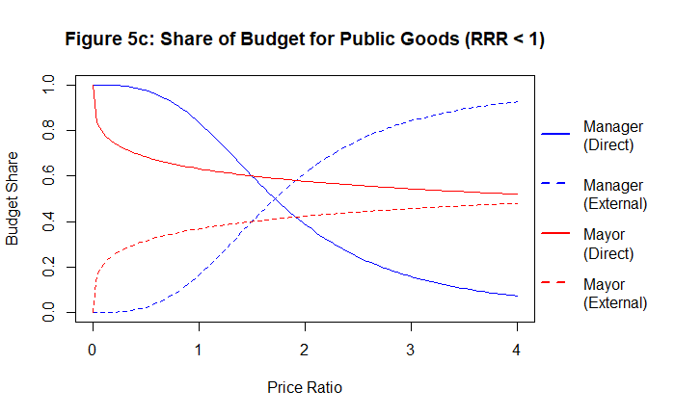

These results generate a series of propositions related to market competition.

### H5: Mayors will be more sensitive to changes in the price ratio than Managers. Specifically, Mayors are more sensitive to low relative price ratios, which are associated with less competitive markets for public good production.

### H6: Mayors are most sensitive to high-cost, high-risk situations. Here, they move almost immediately toward external production.

### H7: A Manager is far less likely to engage in joint production in extreme markets. In cases where the markets are not competitive, Managers will move almost entirely into internal production. Similarly, when the markets are highly competitive, Managers quickly move to shift all production to external providers.

*What mechanism to choose?*

Researchers thus far has had a difficult time answering this question. We argue this is largely due to the failure to properly account for the role of government form in constructing theory. Lubell et al (2005) stated clearly the need to account for the conditional effects of political institutions. However, none of the work in municipal contracting have followed their lead fully. In doing so, we are able to articulate clear and logically consistent propositions for testing.

We previously noted the decision rule articulated by Rodriguez, Tavares, and Arajo (2012). The public official will have the highest demand for the service delivery mechanism that minimizes transaction risk. In our model, a public official will choose the service delivery mechanism that minimizes the transaction risks parameter, whether that be internal risk ($β$) or external risk ($ϑ$). Now, consider the results from Figure 5A-C. One important takeaway is that the relative risk ratio impacts Mayors and Managers quite differently. Mayors are far more sensitive to it than are Managers. This generates our first proposition:

### H8: Mayors will choose internal production if the relative risk ratio ($\frac{β}{ϑ}$) is less than one.

### This means Mayors will only choose external production where ($\frac{β}{ϑ}$) is greater than one.

If internal production carries more political risk than external production, Mayors will seek out the service delivery mechanism that minimizes external production risk ($ϑ$), thereby maximizing political value from distributing the resources. The choice then for a Mayor depends on the ordering of $ϑ_{Other Gov.}, ϑ_{Private }, and ϑ_{Nonprofit}$. Using equation [5], this ultimately comes down to Mayors minimizing $δ_{1}$ and $δ_{2}$ for asset specific goods and $δ_{3}$ and ${ δ}_{4 }$ for difficult-to-measure goods.

Mayors respond to high-powered, transactional incentives. They give to get. At low levels of risk, per Shrestha and Feiock (2011), Mayors can dole out lucrative contracts to private sector patrons. At higher levels of asset specificity though, private contracts are exceedingly difficult to write in a way to ensure future political stability. This means, where the relative risk ratio is greater than one for a Mayor, the external contracting decision ultimately comes down to another government or a nonprofit partner at moderate to high levels of asset specificity. Such a decision ultimately rests on the desire of the Mayor. If the risk is so great that the Mayor wants to shift blame entirely, then she will choose to contract to another government. In eschewing the responsibility altogether, the Mayor insulates herself from the special interest demands of her constituents. However, if the goal is more in line with cost reduction, nonprofits are viable options to an extent (i.e. elder and ADA transport services, ambulance services, etc.). Still, Figure 5B illustrates the relative insensitivity of Mayors to rising relative prices. Therefore, we should expect Managers to be more keen on shifting local production to nonprofits than Mayors. Therefore, we see a general ordering of external production risk ($ϑ_{i}$) for asset specific goods for Mayors as asset specificity for a good/service increases:

High ($α$) $←←←$ Low ($α$)

$$ϑ_{i, Other Gov. }< ϑ_{i, Nonprofit}< ϑ_{i, Private }< β_{i}$$

Measurement difficulty ultimately comes down to the same decision between contracting with a nonprofit or contracting the service out entirely to another government. However, following Feiock and Jang (2009), Mayors may view nonprofits similarly to for profits. In the case of difficult to measure services, Mayors can still gain political favor in giving contracts to local nonprofits. In the case of measurement difficulty, where the relative risk ratio is greater than one, we expect Mayors to seek out nonprofits to fulfill the demands of local special interests.

High ($α$) $←←←$ Low ($α$)

$$ϑ_{i, Nonprofit}<{ ϑ}_{i, Other Gov. }< ϑ_{i, Private }< β_{i}$$

Managers are not Mayors. They appear to be more cost-conscious, make decisions over longer time horizons, and, unlike Mayors, their incentives are aligned with their organizations. Figure 5B again illustrates the importance of the relative risk ratio. Where internal production is riskier than external production, Managers are more likely to produce externally. Managers also appear to be much more sensitive to relative costs. As the relative cost of internal production approaches unity, Managers move quickly to nearly complete contracting out of the good or service. Given their cost sensitivity, it makes sense they would have an interest in private production, particularly at low levels of asset specificity. However, as asset specificity increases, they will be faced with the same choice as Mayors: contract to another government or hire a local nonprofit. Unlike Mayors, Manager’s are rewarded for control, stewardship, and prudence. Hence, contracting the service out to another government eliminates most, if not all, of any potential benefit. Instead, we expect Managers to seek out local nonprofits. For Managers then, we see the ordering of $ϑ_{i}$ progressing in the following way:

High ($α$) $←←←$ Low ($α$)

$$ϑ_{i, Nonprofit}<{ ϑ}_{i, Other Gov. }< ϑ_{i, Private }< β_{i}$$

Measurement difficulty presents a different situation for Managers. Whereas Mayors are driven by the transaction risk parameter, Managers appear to be more sensitive to relative prices. Figure 6 below illustrates this point. Assuming the relative risk ratio is fixed at one, the production decisions will actually move toward opposite outcomes. Mayors will stay primarily in direct production until the direct costs become several times more expensive than external prices. But, as soon as internal prices start approaching one, Managers move swiftly away from direct production toward external production, presumably to save costs.

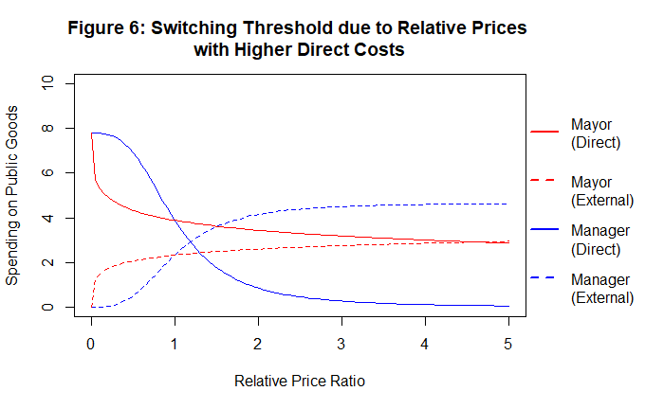

Applying this same logic to the issue of measurement difficulty, we can assume that Managers are seeking out the lowest cost option. As noted for Mayors, nonprofits provide the best option here. They can provide the good or service but without having to make profit margins. Hence, the cost should be cheaper here. However, this is subject to the degree of competition too. In markets where the nonprofit sector is underdeveloped, a Manager may find the option of contracting with another local government more palatable than a dominant (and expensive) nonprofit. In this case, we view this ordering as contingent on market conditions in the nonprofit sector.

High ($α$) $←←←$ Low ()

| Competitive nonprofit sector

The key distinction between Mayors and Managers is their respective sensitivity to transaction risks and relative prices. The mayoral contracting decision is made almost entirely on the relative risk ratio. Mayors will choose the option with the smallest risk. The managerial decision, on the other hand, is far more price sensitive. As relative prices increase to moderate levels, managers move almost explicitly to external production of that good or service. These results generate new and very important implications:

### H9: Mayors are will contract with for-profit organizations when asset specificity is low, but they will most likely contract the good or service to another local government when asset specificity is high.

### H10: Mayors will contract with for-profit firms at low levels of measurement difficulty, but at high levels of transaction risk, they will transition toward nonprofits.

### H11: Managers are more sensitive to prices. They will seek out for profits when asset specificity is low (just like Mayors), but will move toward nonprofits when asset specificity is high.

### H12: Managers will likely keep production of difficult to measure goods in-house (just like Mayors), but at high levels of measurement difficulty they will seek out nonprofits subject to the competitive nature of the nonprofit sector. If the sector is not competitive and relative prices remain high, we expect Managers to shift production to another government.

## The Model

Generally, our model suggests the key factors shaping the policy supply decision are:

1. Total resources
2. Direct costs
3. Relative costs/price ratio
4. Relative risk ratio
5. Absolute risk aversion

We test our theory using a data set constructed by Kwon et al. (2010). Table 1 below illustrates the descriptive statistics of our variables of interest.

|  |  |  |  |  |  |  |  |
| --- | --- | --- | --- | --- | --- | --- | --- |
| **Table 1: Descriptive Statistics** | | | | | | | |
| *Category* | *Statistic* | *N* | *Mean* | *St. Dev.* | *Min* | *Median* | *Max* |
| **Resources** | Own Rev. | 7,960 | 84.04 | 10.30 | 50.87 | 86.45 | 100.00 |
| **Direct Costs** | FTE / Pop. | 6,431 | 1.11 | 0.91 | 0.10 | 0.94 | 7.98 |
| Union % | 8,010 | 48.27 | 18.73 | 8.10 | 56.30 | 80.80 |
| Salaries % | 7,923 | 31.94 | 10.34 | 0.93 | 32.49 | 82.84 |
| **Relative Costs** | Est. Total | 7,431 | 35229 | 55764 | 712 | 10464 | 219933 |
| NPO per 10,000 pop. | 7,431 | 9.25 | 14.98 | 0.09 | 2.56 | 58.29 |
| Total Other Governments | 7,431 | 81.59 | 90.77 | 5.00 | 51.00 | 473.00 |
| **Transaction Risks** | Asset Specificity | 8,028 | 3.11 | 0.62 | 1.75 | 3.11 | 4.22 |
| Measurement Difficulty | 8,028 | 2.65 | 0.55 | 1.53 | 2.58 | 4.29 |
| **Political Institutions** | Party Elections | 7,794 | 0.14 | 0.35 | 0.00 | 0.00 | 1.00 |
| At Large Candidates | 7,698 | 0.54 | 0.50 | 0.00 | 1.00 | 1.00 |
| Mayor-Council Gov. (Yes = 1) | 8,028 | 0.15 | 0.36 | 0.00 | 0.00 | 1.00 |

1. This is referred to as Decreasing Absolute Risk Aversion, where absolute risk aversion represents the change in an individual’s risk tolerance as their income/wealth grows (Pratt, 1964).
2. Ceteris paribus of course
3. We impose the restriction that $0< α_{i}<1$. This ensures our public officials remain risk-averse (as opposed to risk-loving (e.g. $α_{i}>1$) or risk neutral), and that our official exhibits Decrease Absolue Risk Aversion (DARA).